1. Candle doesn’t tell the movement path of that particular share on that particular day as a candle can be formed in various ways.
2. 
3. A screenshot of a graph

   Description automatically generated  
   In the above graphs, we can see, price is reaching 140 3 times and falling down.   
   These 3 points are restriction points which candle doesn’t give us.  
   Jatin: Handle informs us about this point only once by the value of high.
4. 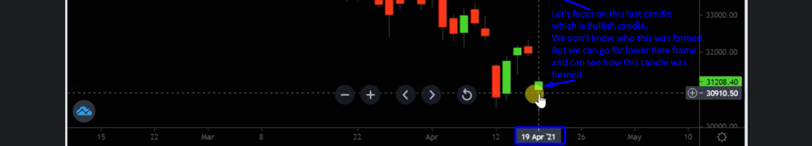  
   
5. A screen shot of a graph

   Description automatically generated